<!DOCTYPE html>

<html>

<head>

<title>Registration</title>

<head>

<body id="c2" bgcolor="black";>

<h2 id="c1"> SPORTS REGISTRATION FORM</h2>

<form action="somefile.html" method="get">

<table>

<tr>

<td id="c">Name</td>

<td><input type="text" placeholder="name" name="username">

</td>

</tr>

<tr>

<td id="c">E-mail</td>

<td><input type="text" placeholder="@.gmail.com">

</td>

</tr>

<tr>

<td id="c">Password</td>

<td><input type="password" pattern=".{6, }" title="six or more characters" placeholder="password" name="password"></td>

</tr>

<tr>

<td id="c">DOB</td>

<td><input type="date" min="1994-08-01" max="2002-08-01" value="2000-01-01" placeholder="dd/mm/yyyy"></td>

</tr>

<tr>

<td id="c">Gender</td>

<td><input type="radio" name="gender">M

<input type="radio" name="gender">F

</td>

</tr>

<tr>

<td id="c">Under Age</td>

<td><select>

<option>Select</option>

<option>16</option>

<option>19</option>

<option>21</option>

</select></td>

</tr>

<tr>

<td id="c">Department</td>

<td><select>

<option>Select</option>

<option>Chemial</option>

<option>Civil</option>

<option>Computer</option>

<option>Electrical</option>

<option>Environment</option>

<option>Mechanical</option>

</select></td>

<tr>

<td id="c">Game</td>

<td><input type="checkbox" name="cricket">

Cricket<br/>

<input type="checkbox" name="football">

football<br/>

<input type="checkbox" name="kabbadi">

kabbadi <br/>

<input type="checkbox" name="volleyball"> volleyball <br/>

<input type="checkbox" > Kho-kho</td>

</tr>

<tr id="c">

<td>city</td>

<td><select>

<option>Select</option>

<option>Delhi</option>

<option>Ahemdabad</option>

<option>Mumbai</option>

<option>Banglore</option>

<option>chennai</option>

<option>Kolkata</option>

<option>Ranchi</option>

<option>Lucknow</option>

</select></td>

</tr>

<tr>

<td colspan="2.3">

<input type="submit" value="Register"></td>

<td><input type="reset"></td>

</tr>

</table>

</form>

</body>

</html>

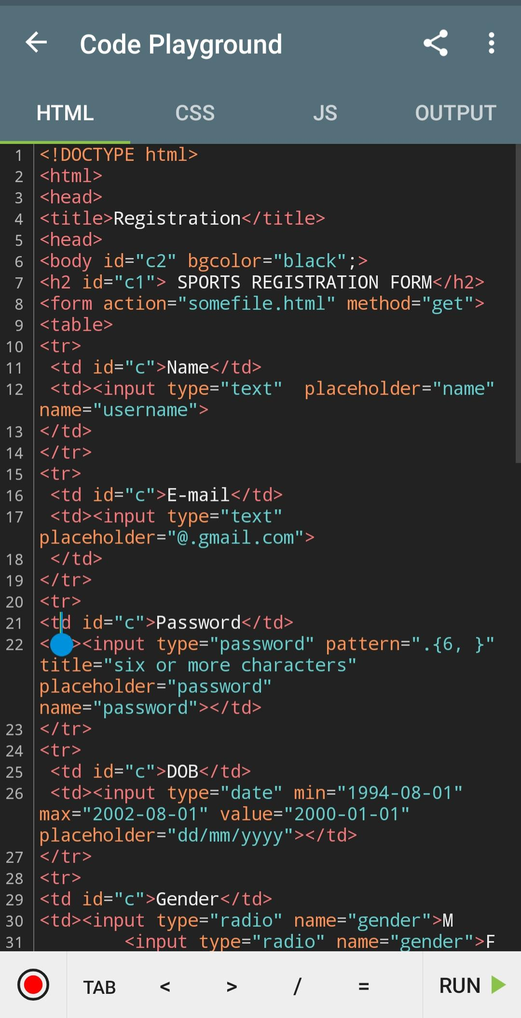

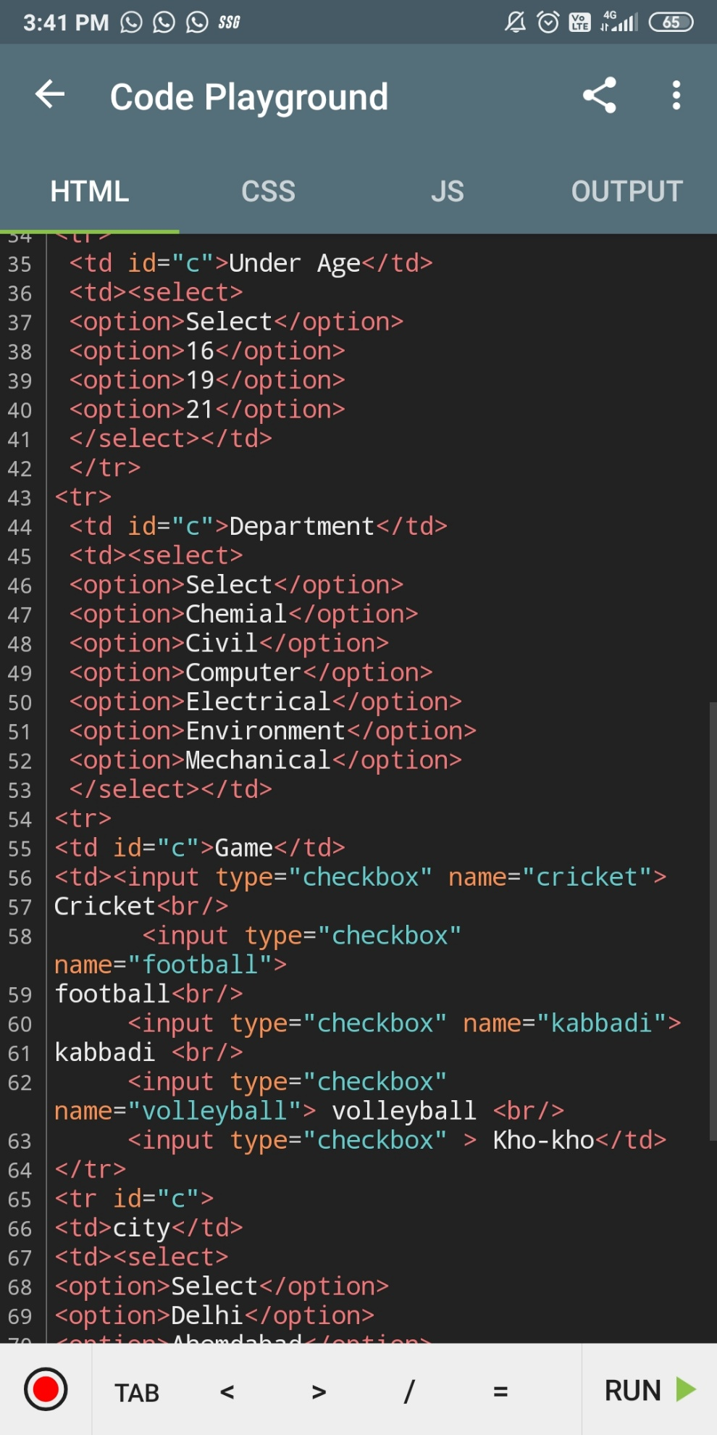

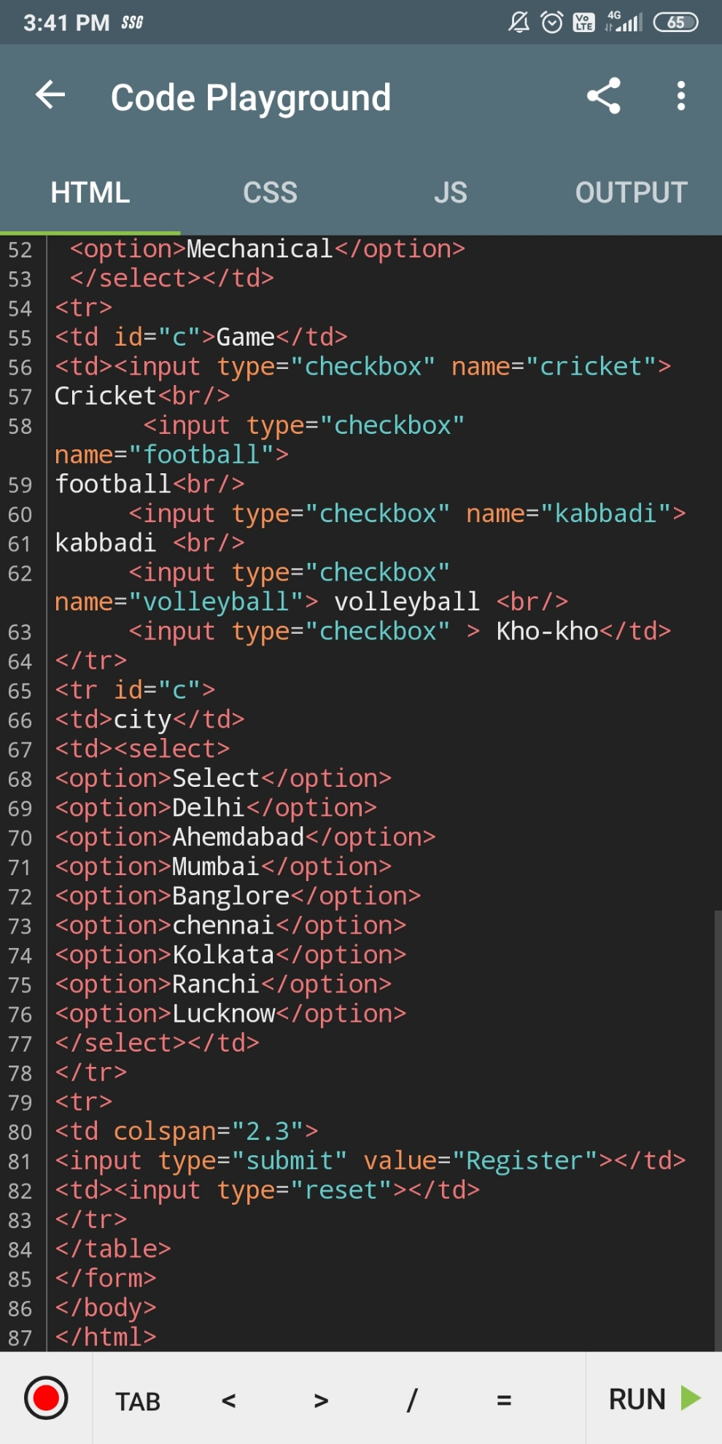

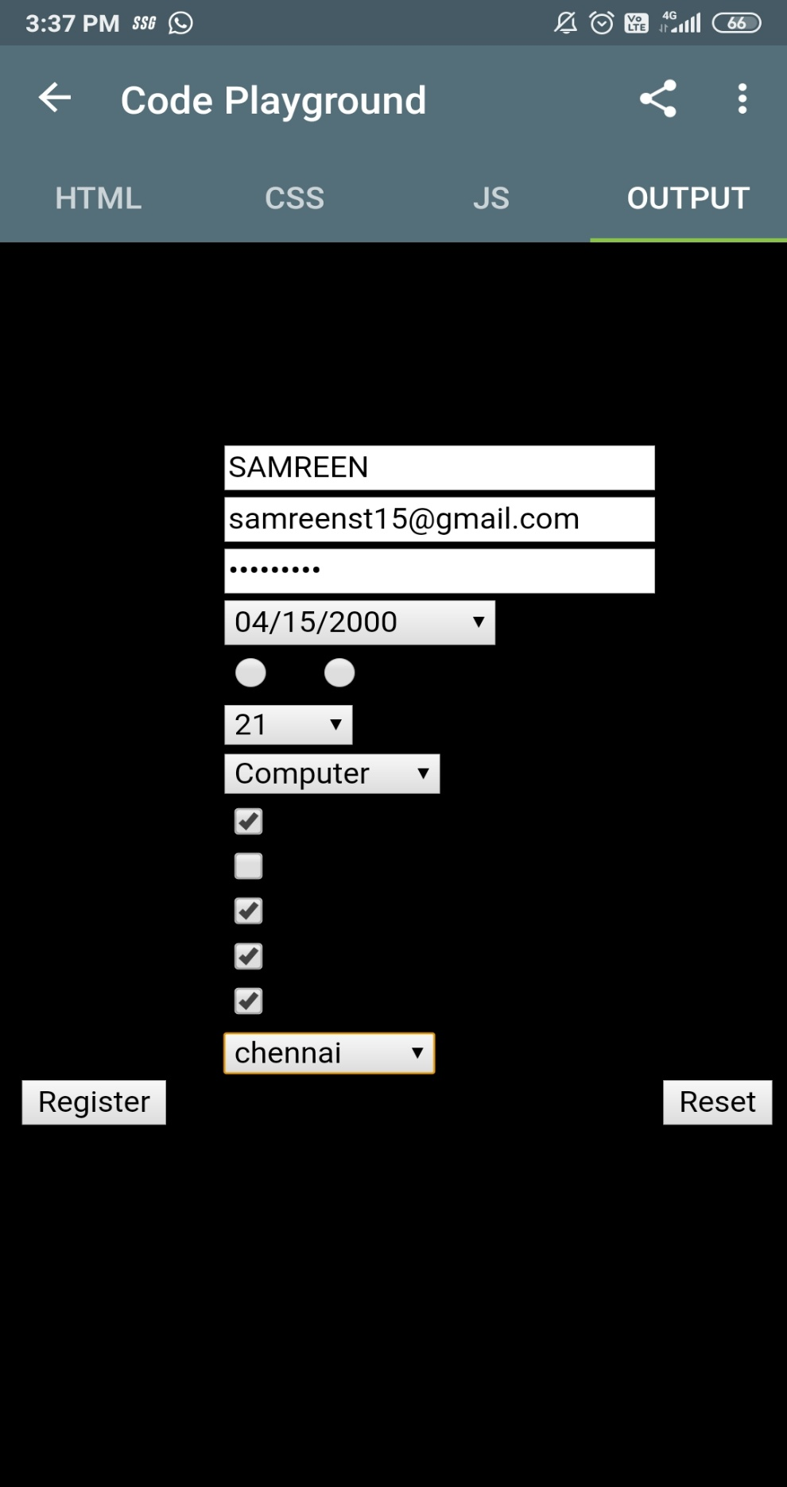**Output**